## PASCAL Charlotte

## What happened to George Floyd?

George Floyd, in his forties, was pinned to the ground on his stomach and immobilized with one knee on his neck. Four Minneapolis police officers were fired Tuesday after the death of a black man following a muscle-bound arrest, a tragedy that sparked anger in the city.

Mr. Floyd groans "please, I can't breathe" and "don't kill me" as bystanders urge officers to let him go. Mr. Floyd ceases to move and an ambulance arrives to take him to hospital where he later died.

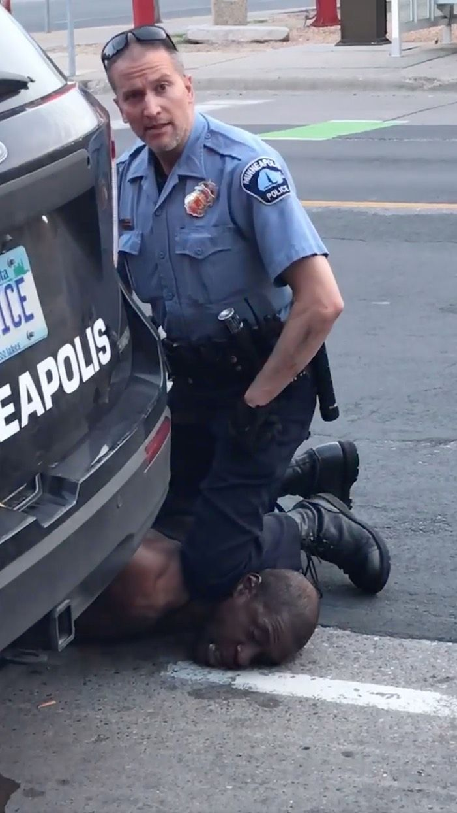

**What was the official response?**

Mayor Jacob Frey said it was the "right call" to fire the officers. He said: "Being black in America should not be a death sentence. For five minutes we watched as a white police officer pressed his knee into the neck of a black man. For five minutes."

The FBI is investigating the incident and will present its findings to the Minnesota state's attorney for possible federal charges.

